**2025 Gilman Certamen: February Festival Frenzy!**

**Salvete magistri magistraeque!**

Gilman School is very happy to host again our annual *Certamen!*

**Quid?** Gilman School *Certamen*

**Quando?** Saturday, February 1, 2025; 10:30-2:00

**Ubi?** Gilman Upper School, Carey Hall, 5407 Roland Ave. Baltimore, MD 21210

**Quare?** Students have the opportunity to test their Classical mettle with their peers and have fun in the process!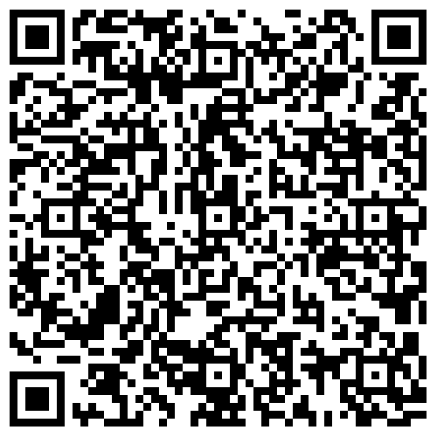

**AGENDA**

Registration: 10:30-11:00 Scan the QR Code to register!

Ice-Breaker: 11:00-11:30

Certamen: 11:45 - 1:00

Lunch 1:00 - 1:45

Activity: TBD

Awards: 2:00 PM

***We will sell pizza, chips, and soda/Gatorade for lunch. NO water will be sold. Please bring a refillable water bottle to use during the day. **CASH ONLY!**

***Brunch/Lunch will be provided for teachers and moderators.

**CERTAMEN**

● The Certamen syllabus will follow that of the NLE syllabus.

● We are going to divide the teams according to levels used at the NJCLs: Beginning (Latin 1), Intermediate (Latin 2), Advanced (Latin 3, 4, AP)

● In addition, expect questions about February festivals and holidays (e.g. Lupercalia, Parentalia, Groundhog’s Day, Presidents’ Day, Valentine’s Day, the Superbowl, etc.)

Every school must submit complete registration information (including numbers of teams and names of moderators) via [Google Form](https://docs.google.com/forms/d/e/1FAIpQLSejQsIV3xd7jDlVGQn6CZMZZ-lSkF5-yOtjsYShWiXjVieFAw/viewform?usp=sf_link) no later than **TUESDAY, JANUARY 28th.**  Please bring cash or checks (made out to “Gilman School”) to the certamen. After January 28th, we cannot necessarily accommodate changes or additions.

**DONATIONS**

Please bring canned meats (e.g. fish, chicken, and spam), cooking oil, soups, and other non-perishable unexpired food to support the Donald P. Bentley Food Pantry.

We’re looking forward to seeing you soon! If you have questions, please don’t hesitate to contact Sarah Miller ([smiller@gilman.edu](mailto:smiller@gilman.edu)).