Multa, quae impedita natura sunt, consilio expediuntur.
“Many things which are naturally difficult are solved by ingenuity.”
Livy, Ab Urbe Condita, XXV.1

MDJCL Spring Convention
“Battle on the Seas”

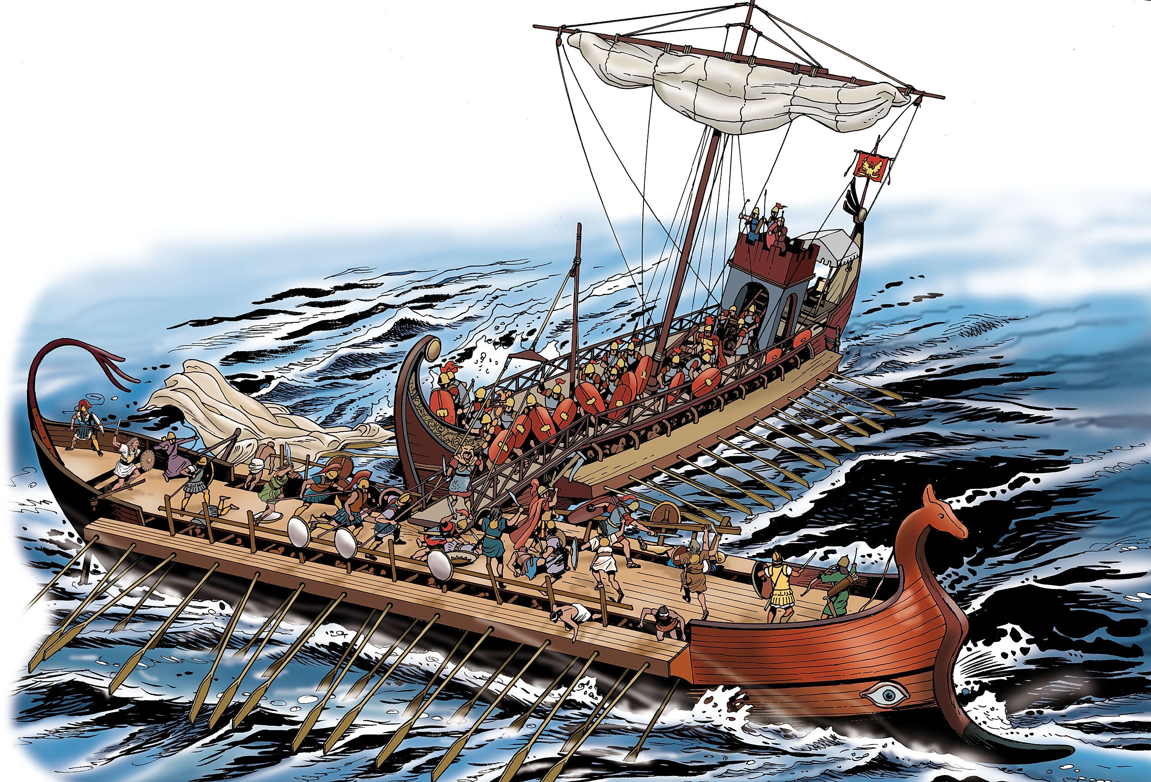

April 20th and 21st, 2024
10:00am Saturday – 3:00 pm Sunday

Easton High School
723 Mecklenburg Avenue
Easton, MD 21601
Tentative Schedule of Events
Time | Events (Saturday)
10:00 – 10:30 | Registration and Muffins
10:30 – 11:00 | Opening Assembly – Introductions, spirit competition
11:00 – 12:30 | Certamen - 3 rounds
12:30 – 1:15 | Lunch
1:15 – 3:00 | Athletics/Ludi
3:15 – 3:45  3:45 – 4:15  4:15 – 4:45 | Colloquia
 | Improptu Art I | Dramatic Interpretation | Diversity Mixer I
 | Improptu Art II | Naval Warfare | Nationals Interest Meeting
 | Naval Warfare | tbd | Diversity Mixer II
4:45 – 5:45 | Academic testing
5:45 – 6:30 | Dinner + Group Picture
6:30 – 7:00 | Meet the Candidates / Question Session
7:30 – 9:00 | That’s Entertainment
Throughout the Day | Game Room, Art display, Bazaar

Time | Events (Sunday)
9:30 – 10:00 | Welcome back!
10:00 – 11:00 | Final Round of Certamen
11:00 – 11:30 | Final Candidate Speeches Election
11:30 – 12:15 | Latin Lunch
12:15 – 1:15 | Gladiator Tournament
1:15 – 2:00 | Award Ceremony + Farewells

Details and other Important Information

Certamen: Certamen is a trivia competition similar to “It’s Academic!” This competition is held at Beginner (Latin ½ and 1), Intermediate (Latin 2), and Advanced (Latin 3+) levels and pits students from different Maryland schools against each other. Categories of questions include: grammar, vocabulary, Greek and Roman mythology, history, literature, and daily life.

Colloquia: Colloquia are interactive, hands-on workshops led by teachers or state officers, meant to encourage interest in a variety of topics and to foster friendships with other Latin students. Here is a brief description of each colloquium:
Naval Warfare with EHS: learn and experience an ancient naval battle in a kiddie pool
Meet the Candidates with everyone running for state office: ask questions about their plans for MDJCL, favorite Latin vocab words, and whatever else helps you choose wisely
Nationals Interest Meeting with MDJCL Officers: anyone interested in attending the National JCL convention this summer, let’s get together and make some plans!
Impromptu Art run by EHS. You will be given a baggie of mandatory materials to include in a 25-minute creation on a surprise theme. More supplies will be available and you are allowed to bring whatever supplies you wish to use. A winner will be chosen from each session.
Diversity Mixer with State Officers: a fun and interactive way to get to know other cool Latin nerds from various backgrounds! Make new friends with music and games!

Game Room: Throughout the weekend there will be a room with a variety of board games played. This is where students should go if they need a break or are not participating in the main activity. We will be playing
CARD-tamen (a card game where gods are pitted against buildings against historical figures etc.)
Verba (a Latin version of Apples to Apples!!)
Rota (a Roman soldier’s game, kind of like Tic-Tac-Toe)

Dramatic Interpretation: Are you an actor at heart? Do you like to do dramatic readings? The Dramatic Interpretation Contest is designed for just such students. Participants will memorize an assigned passage and deliver it dramatically (with appropriate emotion and gestures). Students will be assessed on the accuracy of their Latin and on their style of delivery. The selected passages can be found at the NJCL website https://www.njcl.org/NJCL-Convention/Convention-Contests/Creative-Arts-Contests

We would really love to see more students participating in all categories! Be bold!
Art Projects
This year we will be having a prepared art showcase. You can submit pieces to the art showcase for judging and observation, but they must be prepared before the convention date

Art Showcase
Students can submit artwork in any of the following categories:
• 2D art
• 3D art, including models
• Historical/mythological scene recreation with marshmallow Peeps
- Scrapbook (may be digital or physical)
Submissions will be judged on the basis of:
• Originality/Creativity
• Design and Color
• Effect of Humor/Message
• Accuracy/Authenticity
• Neatness
• Correct Latin/English explanations
• Overall Effect

• Adherence to category’s rules
(2D art must be flat, 3D art should rise off a surface, and mosaics MUST contain more than 3 pieces of material. Peep diorama must use marshmallow peeps to represent people or animals and represent an event from ancient history/mythology. Scrapbooks should contain photographs, and will be judged on how closely they adhere to the definition of “scrapbook” in the Merriam-Webster dictionary: “(noun) a blank book in which various items (as newspaper clippings or pictures) are collected or preserved”.

Bazaar: Does your Latin club have a cool tee-shirt that you would like to sell? Do you have buttons, magnets, or any other classical item you could sell in our marketplace? Latin clubs are invited to bring whatever items they have to sell; proceeds will go to individual clubs. The bazaar will be open for business throughout the weekend and you must have a student to staff your part.

Post Cenam
That’s Entertainment : We want to see how impressive all our members are—whether related to their Latin skills or not. Please prepare a peformance to show off your talents, whatever they may be. We welcome singing, dancing, skits, playing of instruments, acrobatics, martial arts, and more skits. Last year there was an amazing Rubiks cube performance…
Please bring whatever music and props you need.

Ludi

Golden Apples Race: a race, with a twist: each contestant must acquire an “Apple” (balls thrown onto the course by the referee) in order to cross the finish line.

Ultimate Discus: Who says Latin is just book work? For the ultimate competition, we’ve taken the awesome sport of Ultimate Frisbee and turned it into Ultimate Discus! Band together with friends (or athletically inclined classmates) and compete to be the ultimate Ultimate Discus team in all Maryland JCL! Let the games begin!
Capture the Helen: Just like capture the flag… but with Helen..
There will be two teams, The Greeks and the Trojans. The Greeks line up on one side of the field and the Trojans line up on the other side. Each team will have 4 items placed in hula-hoops on their side Helen, Paris, a football, and a Frisbee. Each team’s goal is to capture the items and bring them back to their side. The football and the Frisbee must be thrown across the centerline while Helen and Paris must be carried. Meanwhile, the other team works to tag them and send them to the “jail”. The jail is the group of cones at the end of each teams side. A player can free teammates from jail by touching a team member in jail. ALL teammates in jail are released and must go back to their side before trying to capture items. If tagged while holding an item the item must be returned to its original hula-hoop and the player goes to jail. Once a player reaches a hula-hoop they are “safe” and can remain in the hula-hoop as long as they wish. Only one person may be in a hula-hoop at a time. Defending players must be at least 10 feet away from hula-hoops when no one is in them (ie. No cherry picking). After a team captures items they should give them to the official scorekeeper. The first team to capture all 4 items wins.

Gladiator Tournament: Students will compete one on one…gladiator-style!
To win a player must “hit” their opponent specifically in their arms and legs. If the opponent is hit they “lose” their limbs and must evade the other hits. For example, if they are hit in the leg they must hop on the other foot for the rest of the match. However, players are permitted to wear armor, which adds one layer of protection which then must be removed. To clarify, armor is like an extra “life” in that specific limb even though it might not protect the entire limb in truth. Players are permitted, if they wish, to bring their own “weapons” as long as they adhere to the guidelines below. Players must remain in the specified area during the fight. Hits to the head are strictly forbidden and sportsmanship is of utmost importance. Failure to adhere to these rules will result in the player’s removal from the tournament.

Guidelines and Tips for Weapons and Armor:
- Armor must be in some way authentic to classical armor (mostly in appearance).
- Any type of weapon can be used as long as it is padded sufficiently with foam or similar
- The whole weapon must be padded. No sharp edges.
- A moderator must approve ALL weapons before use.
- Moderators of the Tournament reserve the right to refuse any armor and weapons if deemed unacceptable of any reason.
- NERF like swords may be provided to all participants or you may bring your own

Election Information
One of the best things about MDJCL is that the student officers have a lot of control over the agenda and activities of the organization. Want to be one of these amazing people? Run for office!

Being an officer in MDJCL requires quarterly meetings with the rest of the MDJCL board. An integral part of being an MDJCL officer is attendance at these board meetings. Since we do not meet that often, the most important part of being an officer is frequent correspondence and communication through email/text. We brainstorm, discuss, and plan. We establish schedules and judging criteria; we assign jobs large and small; we talk out kinks in the membership drive, the activities, and the individual clubs’ participation.

We would like representation from as many schools as possible—please consider applying!

MDJCL Offices Open:
- President-Presides over the board meetings and may speak on behalf of MDJCL when the occasion arises. He/she stays aware of the activities of the other officers and assists them when appropriate.
- Vice President- Assists the president and the other officers, while in charge of the promotion and membership of MDJCL.
- Parliamentarian- Presides over the election and the MDJCL constitution. This entails keeping up correspondence with candidates and supervising the rules for eligibility.
- Historian- Keeps a record of the year's history and events, including Latin events in the surrounding area. Corresponds with NJCL to get information about national activities. In charge of photographing events and activities over the course of the year and, if extra ambition, creating a scrapbook at the end.
- Editor- Creates an issue of The Torch to be distributed at each Certamen event, and works with the board to make decisions.

(see attached application for requirements)

Amendments
If any school would like to propose changes to our constitution, please bring it to the attention of one of the officers before April 5th and it shall be addressed.

MD Junior Classical League
Officer Candidate Application

Name: School:

2023-24 Latin level:

email address: cell phone:

Circle the office for which you are applying:

President Vice-President Parliamentarian

Historian Editor

As an officer in MDJCL you are required to attend virtual board meetings, held monthly. Since we do not meet that often, the most important part of being an officer is frequent correspondence and communication through email. We brainstorm, discuss, and plan. We establish schedules and judging criteria; we assign jobs large and small; we talk out kinks in the membership drive, the activities, and the individual clubs’ participation. Your signature and your parent’s signature here says you understand that attendance is mandatory at these meetings.

Requirements for Office:

- Compose a short paragraph from one of the two prompts below for a pre-election newsletter. Email this to ikunz@talbotschools.org by April 15, 2024. Maybe include some fun facts also?
  - Share one experience you have had with your local JCL chapter this year that demonstrates your capacity to be a leader.
  - Give and explain one idea that you have for making MDJCL a better organization in the future.
- Complete this form (with the signed teacher recommendation) and bring it with you to convention.
- Bring an election poster with your picture on it to the convention.
- Compose a speech (not to exceed two minutes) to be delivered at the convention.
- Be prepared to answer questions about your qualifications and motivation to succeed at your office. Also be ready to answer silly questions about favorite gods or emperors

Teacher’s Name: ________________________ Signature: _____________________ Date:

Your signature: _________________________ Date:

Your parent’s signature: ________________________ Date:

Art Contest
School _____________________________________
Name _______________________________
Type of Art (circle one): 3D 2D Peeps Scrapbook
Title of Art ______________________________
- - - - - - - - - - - - - - - - - - - - - - - - - - - - - - - - - - - - - - - - - - - - - - - - - - - - - - - - - - - - - - -
Art Contest
School _____________________________________
Name _______________________________
Type of Art (circle one): 3D 2D Peeps Scrapbook
Title of Art ______________________________
- - - - - - - - - - - - - - - - - - - - - - - - - - - - - - - - - - - - - - - - - - - - - - - - - - - - - - - - - - - - - - -
Art Contest
School _____________________________________
Name _______________________________
Type of Art (circle one): 3D 2D Peeps Scrapbook
Title of Art ______________________________
- - - - - - - - - - - - - - - - - - - - - - - - - - - - - - - - - - - - - - - - - - - - - - - - - - - - - - - - - - - - - - -
Art Contest
School _____________________________________
Name _______________________________
Type of Art (circle one): 3D 2D Peeps Scrapbook
Title of Art ______________________________

MDJCL Spring Convention 2024 Registration Information

Registration MUST be completed online this year by each individual attendee.
-- please find the link at mdjcl.org or our other social media sites --

Payment may be made through Paypal online or with check, cash, or Venmo upon arrival.

*please register soon so we can gaurante your t-shirt size and food preferences*

Pecunia

The $55 attendance fee helps us pay to use the building and all materials, but will also guarantee each student a lunch on Saturday (sandwiches), a dinner on Saturday (Chipotle), lunch on Sunday (pizza), and a state t-shirt. The hotel includes free breakfast for Sunday morning.

If your students wish to bring their own food and not pay for the food we will provide, they may pay a $30 attendance fee. Chaperones who wish to attend and participate in meals may pay a $30 fee as well. Please indicate this on your registration.

We have reserved two blocks of rooms at an adjacent hotel very near the school (~5 minute drive) at a discounted group rate:

The Holiday Inn Express
8561 Ocean Gateway
Easton, Maryland 21601
(410) 819-6500
($155/room)

Reservations must be made by individuals and paid for directly to the hotel, though we encourage students to share rooms. The rooms will be held until a week before.

**we would like to offer some need-based “grants” to students who wish to attend but whose families are unable to pay the fee. Please contact Magistra Kunz (ikunz@talbotschools.org) about this privately.

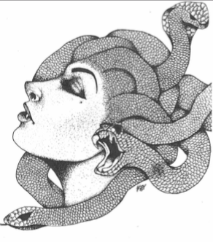
MDJCL State Convention
Preparedness Checklist!

Use this to plan ahead and the night before as your last-minute packing list!

Things to start preparing 2+ weeks ahead of time:
Dramatic Interpretation Passage
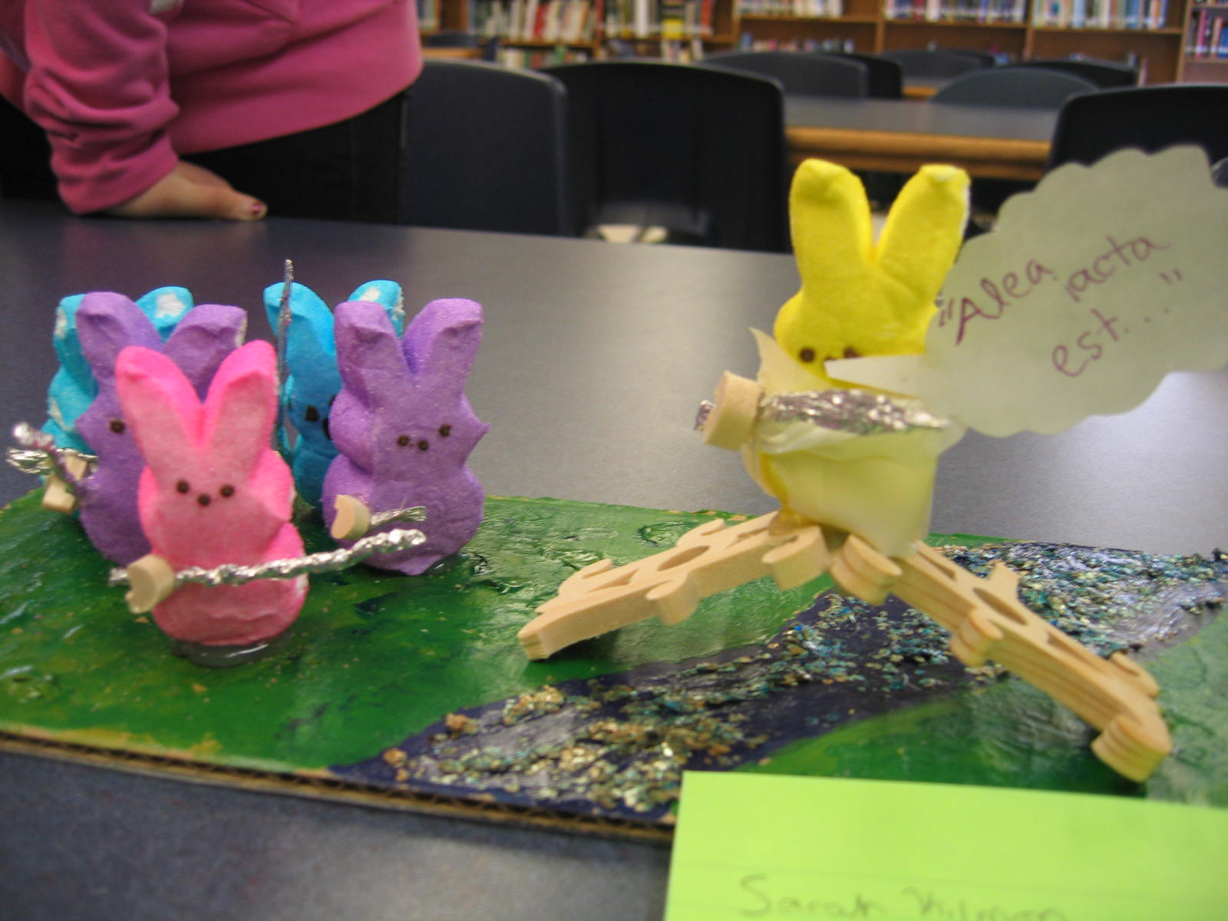
Peep diorama
2D Art/3D Art/Scrapbook
Skit/song/dance/other performance

Things to start thinking about 2+ weeks ahead of time:
Should I be a state officer?
Is there an area of Certamen I should study for?
Do I need to work on my frisbee-throwing skills?

Basic packing list for everyone:
Deodorant. Seriously, people.
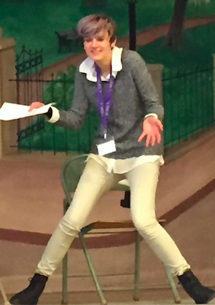
Toothbrush/paste. Hairbrush.
Pants/skirt.
Underwear/socks.
(you might not need an extra shirt since you’ll get the State Shirt to wear Sunday)
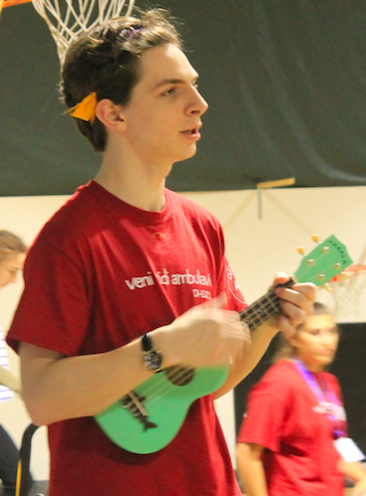
Cash for bazaar things.
Phone charger. Phone. Wallet.

Packing list for specific part of convention:
Musical instrument or other props for That’s Entertainment
An extra frisbee to practice
Gladiator weapons
Things to sell at Bazaar
Neat books/nerdy things to show your new friends
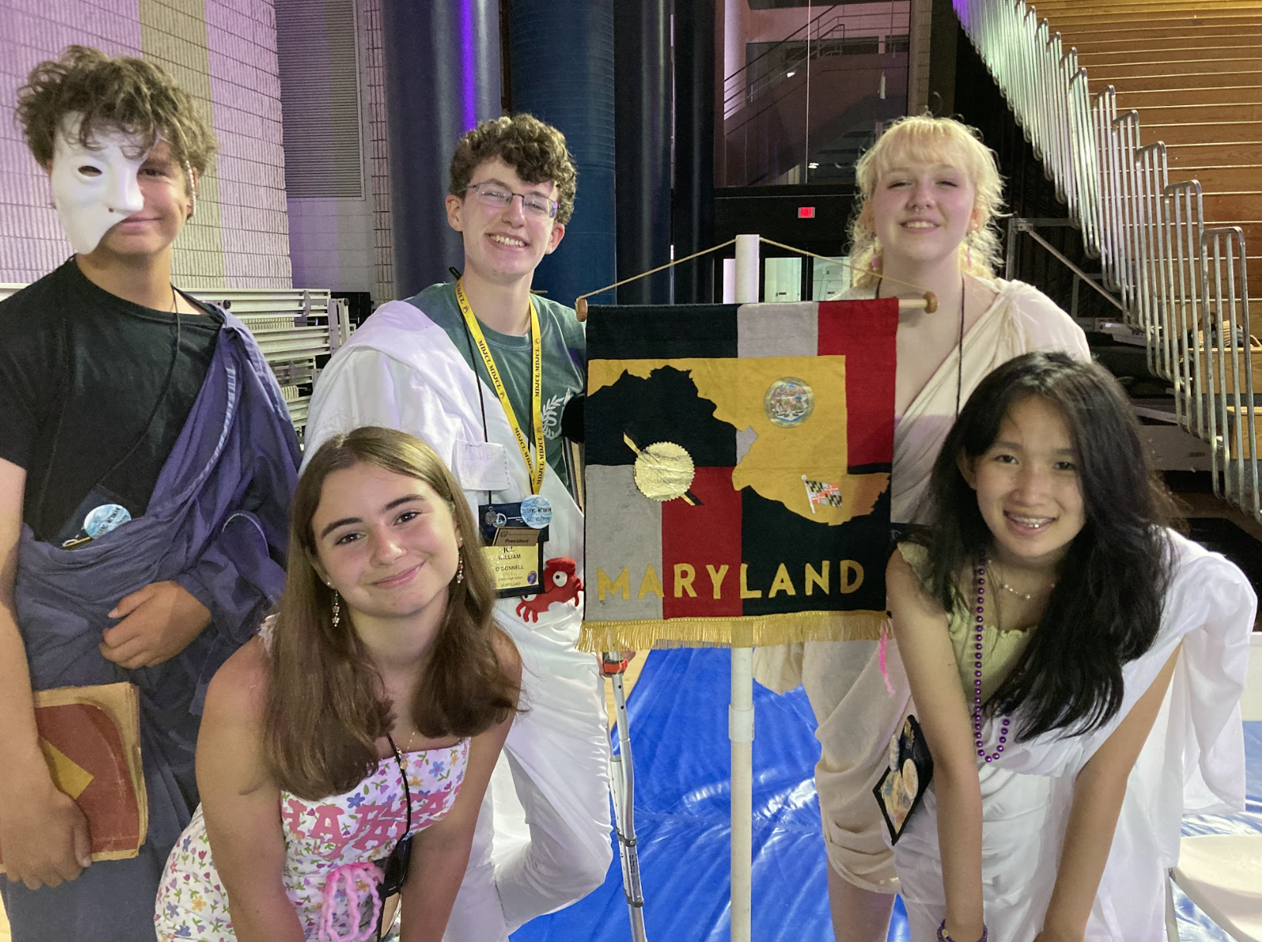
Officer form signed by parent/teacher and your speech!

